

SQL Learning

Nithish Gowda

27-05-2025

|  |  |
| --- | --- |
| **SQL** | **NoSQL** |
| Data is stored in tables with rows and columns (Structured data) | Data can be stored as key value pairs,JSON documents , wide column stores, or graph |
| Banking Systems,ERP System, Application requiring complex queries and transactions. | Social Media Platform, IOT data storage, real time analytics,and bigdata application |
| EX: PostGre SQL,MySQL,Oracle,SQL Server | Ex: MongoDB,Cassandra,Redis,CouchBase. |

# Types of Commands in SQL: **DDL, DML, TCL, DCL, DQL.** Tip : 1. Always use COMMIT & ROLLBACK carefully to avoid unintended changes, especially in critical DB. 2.Practice using SELECT frequently to understand your data before making changes with DML commands. What is the difference between SQL & NoSQL DB?

# Detailed explanation of commands : **DDL (Data Definition Language)**:

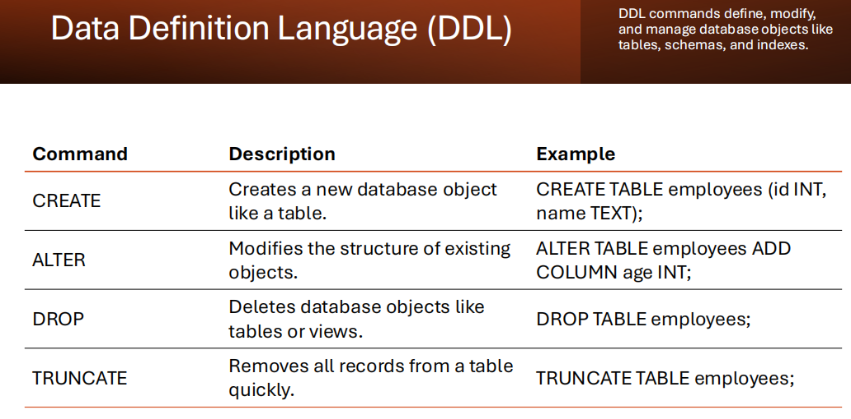

**DML (DATA MANIPULATION LANGUAGE):**

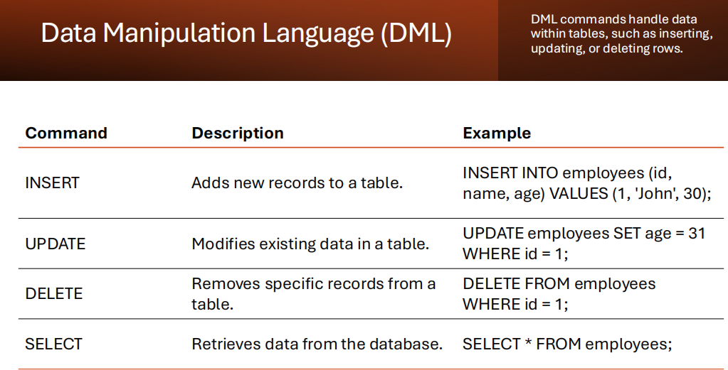

**TCL (Transaction Control Language):**

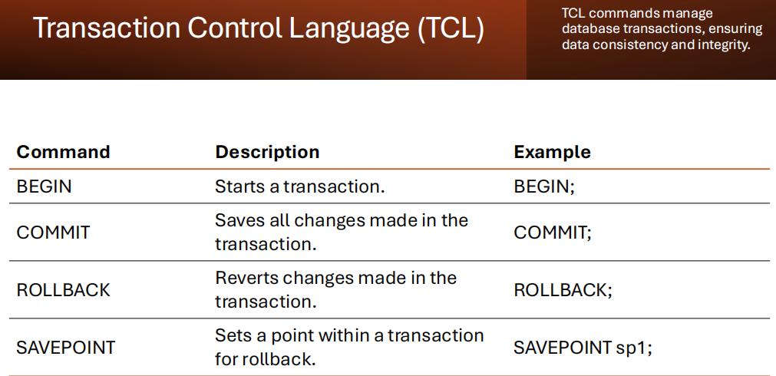

**DCL (DATA CONTROL LANGUAGE):**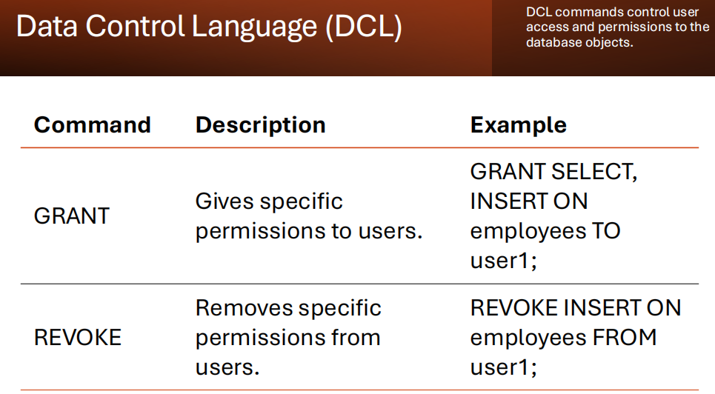

**DQL (DATA QUERY LANGUAGE):**

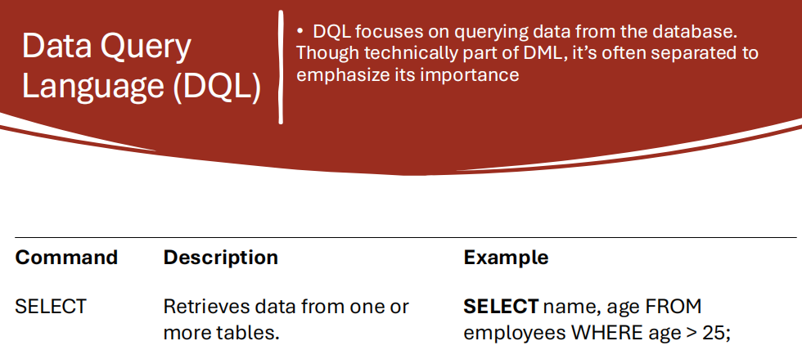

Difference between SQL & NoSQL?  
  
